 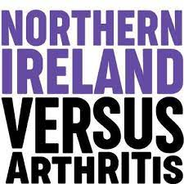

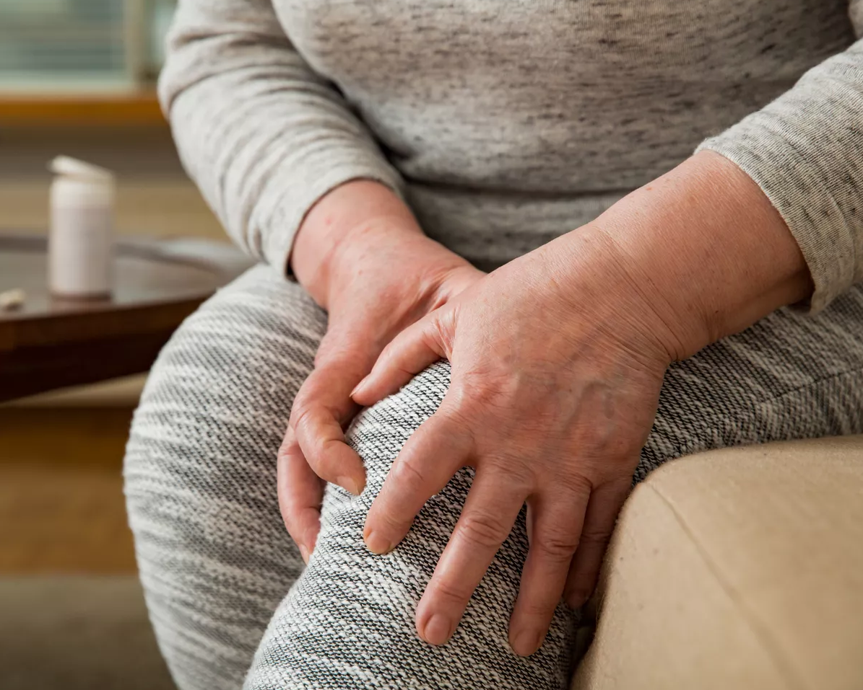

**Living Well with**

**Knee Arthritis?**

**The Do’s and Don’ts for managing your condition**

**Thursday 30th January 2025**

**2-4pm**

**St Mark’s Parish Church Hall**

**Church Street, Newtownards**

**BT23 4AN**

**Book your free place by scanning the QR code:**



