 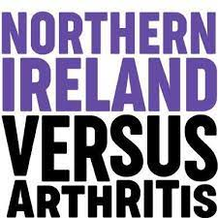

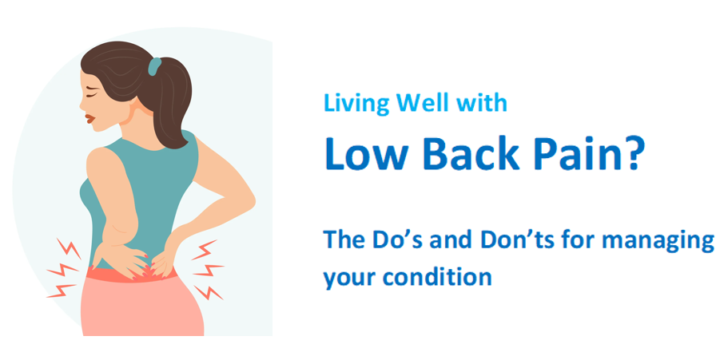

**Thursday 27th March 2025**

**2-4pm**

**Comber Community Centre**

**1 Park Way, Newtownards**

**BT23 5AR**

**Book your free place by scanning the QR code:**



**https://www.eventbrite.co.uk/e/living-well-with-low-back-pain-tickets-1206830796399?aff=oddtdtcreator**

