Need a new hobby?

Are you interested in beginners Watercolour Art Class?
The benefits of art classes for adults are numerous, including helping you unlock your creativity and improving your mental health.

Meet New People Improve Brain Function 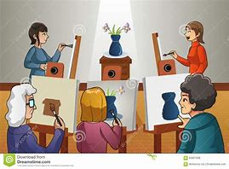 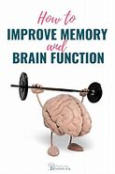

Relieve Stress and Have Fun Develop Your Creativity
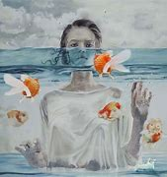

We hope to start sessions with a number of spaces available.

For more information and to register you’re interest please contact:

Nicola Craig

Social Work Assistant at Donaghadee Health Centre.

